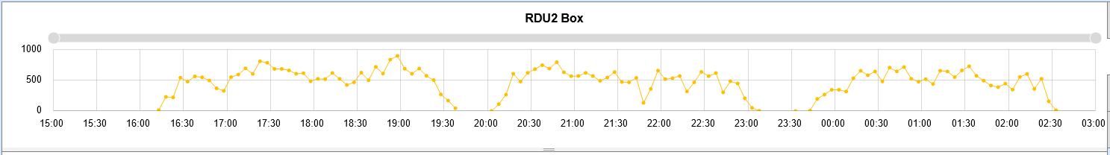
Figure 1: Example of consistent PID Performance 03/07 Nights
Executive Summary
In Weeks 10 and 11, PE supported RDU2 Operations leaders on FHN and BHN with the goal of improving flow to increase throughput. In Weeks 10 and 11, the night shifts were able to execute on 12.3% more Pid Cartons (PC) with 5.43% higher TP CPLH (34.2->36.06) compared to the previous four weeks based on a small set of actions that immediately improved flow (Appendix A).
These actions involved staffing inbound dock to a 100 blended IB Dock CPLH, visually verifying the source of recirc before splitting or adjusting headcount, and adjusting headcount balance to maintain an average of 1000 carriers. The latter two actions became critical during P3 in order to break the cycle of running carriers to <100 in P3 when associate attendance is known to be a barrier (see Figure 1 above for an example of maintaining throughput through P3).
Inbound Dock Staffing
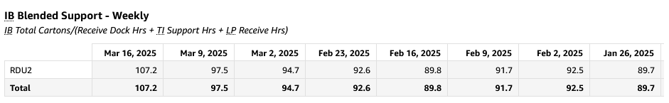
Figure 2: Historical Blended IB CPLH
As indicated in Figure 2, IB Blended CPLH is combined cartons divided by the total hours in Receive Dock, TI Support, and LP Receive. When determining a baseline in the Neo Shift Planner for how much headcount is required in Inbound Dock, RDU2 OMs were advised to plan for a 100 IB Blended CPLH.
The following is the rough math behind achieving a 70K PID carton shift with 300 PR at 67 CPP:
- PID Cartons: 70K
- PR Cartons: 300 * 67 = 20K
- Combined cartons: 90K
- Total IB Dock Headcount: (90K/10 hours)/100 IB CPLH = 90 HC
A headcount plan for the above throughput was created with the FHN team based on historical headcounts, divert percentages and rates (Appendix B).
An important note here is that one variable can throw a wrench into these assumptions: Pallet Receive. If Pallet Receive swings significantly in either direction, Ops should plan for a swing in the same direction of IB CPLH.
Recirc Strategy
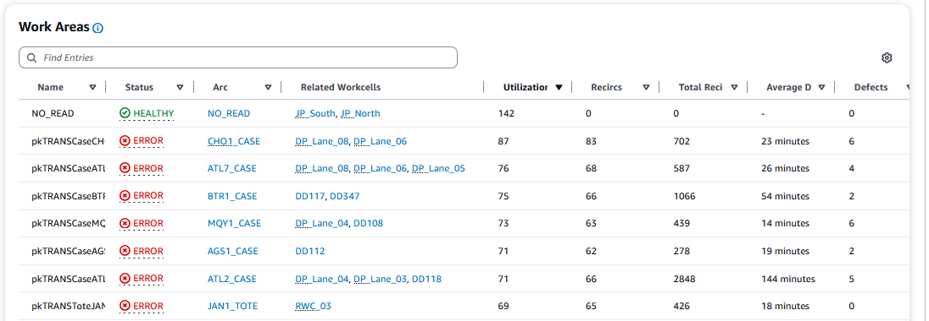
Figure 3: DockFlow Mainsorter Example
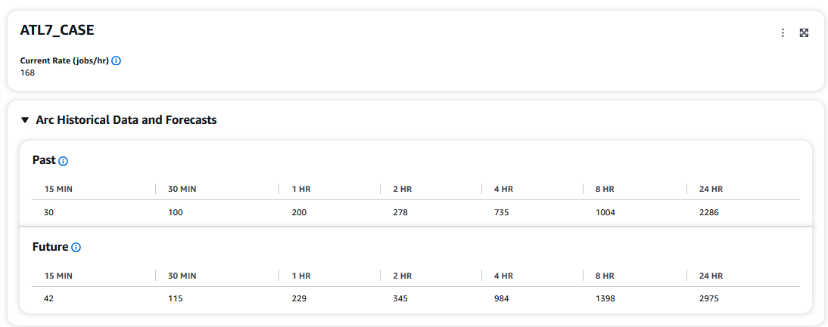
Figure 4: DockFlow Arc Example
On the OB departments’ end, opportunity was observed with labor movement to directly address recirc. Additionally from the Flow team perspective, teams were consistently too willing to split arcs to EOL without auditing the currently allocated destinations and addressing any operational barriers. Flow and OB teams should be working in tandem to identify recirc opportunities, address them primarily with labor movement, and address them secondarily with splitting arcs. This is the key to remaining as close to the allocation plan as possible.
To make this decision making repeatable, OB and Flow teams should be cross referencing the Dockflow Workcell view for “MainSorter” (where they can see carrier utilization) with the Dockflow Arcs view for top utilization arcs. For splitting to MPs/Robots, the math involves adding up all of the currently allocated arcs to each MP/Robot versus theoretical capacity for one MP/Robot. For fluid load, the math is significantly more straightforward because only one arc can be allocated per door (or technically two if you count _CASE and _TOTE separately). Refer to the attached decision-making tables for when to split arcs (Appendix C).
Codifying the decision making for every possible arc split is beyond the scope of this document – however RDU2 Flow and OB teams should follow the following guidelines:
- Start every shift by running the allocation plan which should be optimized for fluid utilization, robots utilization, and pure loading.
- As the shift is in progress, Flow team should be auditing the top utilization arcs in DockFlow or Grafana and in general splitting only if:
  - The conservative theoretical capacity (Appendix C, Figure C.1) of the currently allocated destinations for said arcs is projected to be exceeded.
  - The conservative theoretical capacity of the currently allocated destinations cannot be met for MHE reasons and therefore cannot be met.
- When the two conditions above are not being met, root cause for increased utilization should be determined by Flow and OB teams such as: jams, idle time, insufficient headcount, etc.

P3 Strategy
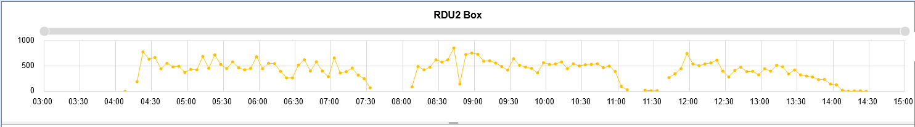
Figure 5: 03/07 Nights indicating good example of P3 Execution (top) vs. 03/11 Days indicating opportunities in P3 Execution (bottom)
In Figure 5 above, there is an apparent (~3500 PC) advantage to be gained by properly balancing headcount in P3. The points below detail the strategy that was employed on 03/07 to both execute during P3 and hand off >1000 carriers to the following Day shift.
The following P3 execution points are applicable to virtually any site or corner that consistently loses carriers and throughput specifically in response to AA early-outs in P3.
- Prior to end of P2, each department should pull an on-prem report to know exactly how much headcount is located within the building that can be labor shared to them, if required, in P3.
- Tenets of the “Recirc Strategy” in the previous section should be applied when deciding to split in P3.
- AMs should have a channel for requesting labor share, this should be leveraged heavily in the first 30 minutes of P3 to cover any apparent gaps
- OMs should specifically be working in tandem with flow to expedite labor moves that are resulting in increased utilization on the crossbelt (prioritized by carriers utilized).
- OMs, Flow, and IB Dock should be monitoring carriers closely. If the historical trend is for carriers to trend down in this quarter, all of the aforementioned parties should monitor the carriers and identify a threshold (BHN used 900 carriers) at which inbound dock should start to either send out headcount or remove them from injecting to the PIDs and reallocate them to moving palletized volume (BHN shifted 5 AAs at a time off of the PMTs). The lower the carriers trend relative to the threshold, the more quickly headcount should be labor shared off of the PMTs.
Appendix
Appendix A: WK6-11 Carton and CPLH Performance
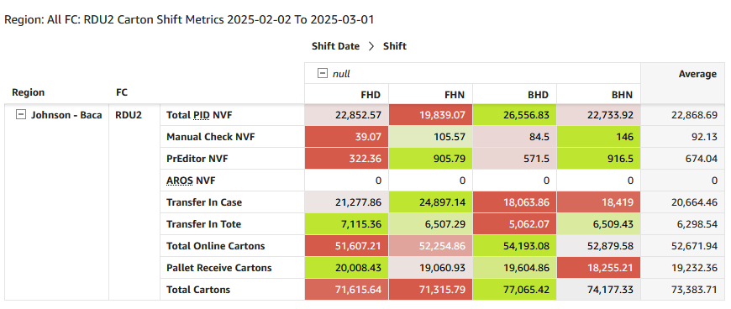
Figure A.1: Week 6 to 9 Carton Averages
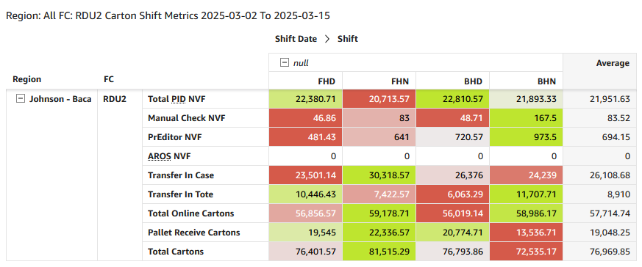
Figure A.2: Week 10 and 11 Carton Averages
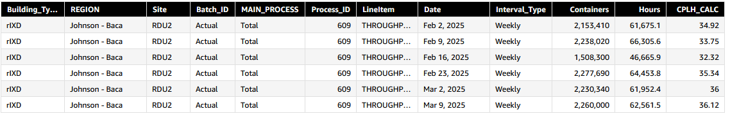
Figure A.3: Week 6 to 11 Weekly Throughput CPLH
Appendix B: Bottom-up headcount plan for 90K combined carton shift
Role | Headcount
Inbound Dock (Including FIPS) | 95
RP - Offline | 8
RP - Receive | 8
Decant | 15
Pallet Prep | 4
NPC | 4
RP - Waterspider | 8
5lb Induct | 26
5lb Wrangler | 26
5lb Super User | 5
5lb PS | 5
20lb Induct | 9
20lb Wrangler | 9
20lb Super User | 2
20lb PS | 2
Case Prep | 4
Man Sort | 25
MS PS | 2
Water Spider | 9
Fluid Load | 63
TDR | 6
Fluid - Sweeper | 2
Direct Palletize | 14
EOL - Driver | 12
Robots | 6
EOL - WS | 4
JC | 22
Problem Solve | 50
 | 445

Figure B.1: Bottom-up Headcounts
Execution Bucket | Qty
PID Cartons | 72000
Pallet Receive | 300
Diverts | 86000
FL Diverts | 63000
MP Diverts | 11000
Robots Diverts | 12000
5lb Volume | 190000
20lb Volume | 50000
MS Volume | 65000
Total Sort Volume | 305000

Figure B.2: Bottom-up Plan Execution Targets
Rate | Value
FL Rate | 100
MP Rate | 78.57143
5lb Rate | 730.7692
20lb Rate | 555.5556
MS Rate | 260
Total Sort Rate | 258.9134

Figure B.3: Bottom-up Plan Rate Assumptions
Appendix C: Arc Splitting Decision Tables
 | Headcount | Proj. Rate | Capacity / Hour
Fluid | 2 | 100 | 200
MP | 2 | 100 | 200
Robots | N/A | 380 | 380
Figure C.1: Conservative Theoretical Capacity by Modality
Case Vol./Hr. | Tote Vol./Hr. | No. Fluid Req. | No. Robots Req. | Number of MP
<200 | 0 | 1 | 0 | 0
<100 | <100 | 1 | 0 | 0
0 | <200 | 1 | 0 | 0
200-300 | 0 | 1 | 0 | 1-2*
0 | 200-300 | 1 | 1 | 0
300-400 | 0 | 2 | 0 | 0
0 | 300-400 | 2 | 0 | 0
400-500 | 0 | 2 | 0 | 1-2*
0 | 400-500 | 2 | 1 | 0
Figure C.2: General Guidelines for Splitting
*Need can vary based on other arcs allocated to same MP

